

ADVANCED PROGRAMMING

Screenshots



Dan Abbagnale (21706092)

CO650

Guy Walker

# TASK1

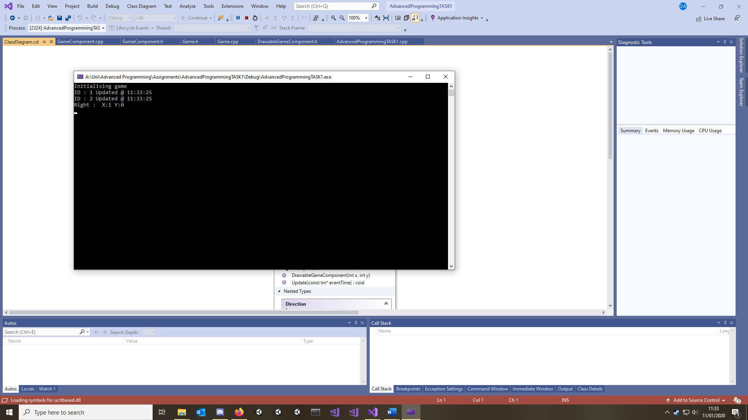

Figure , Game Initialised (1 Second)

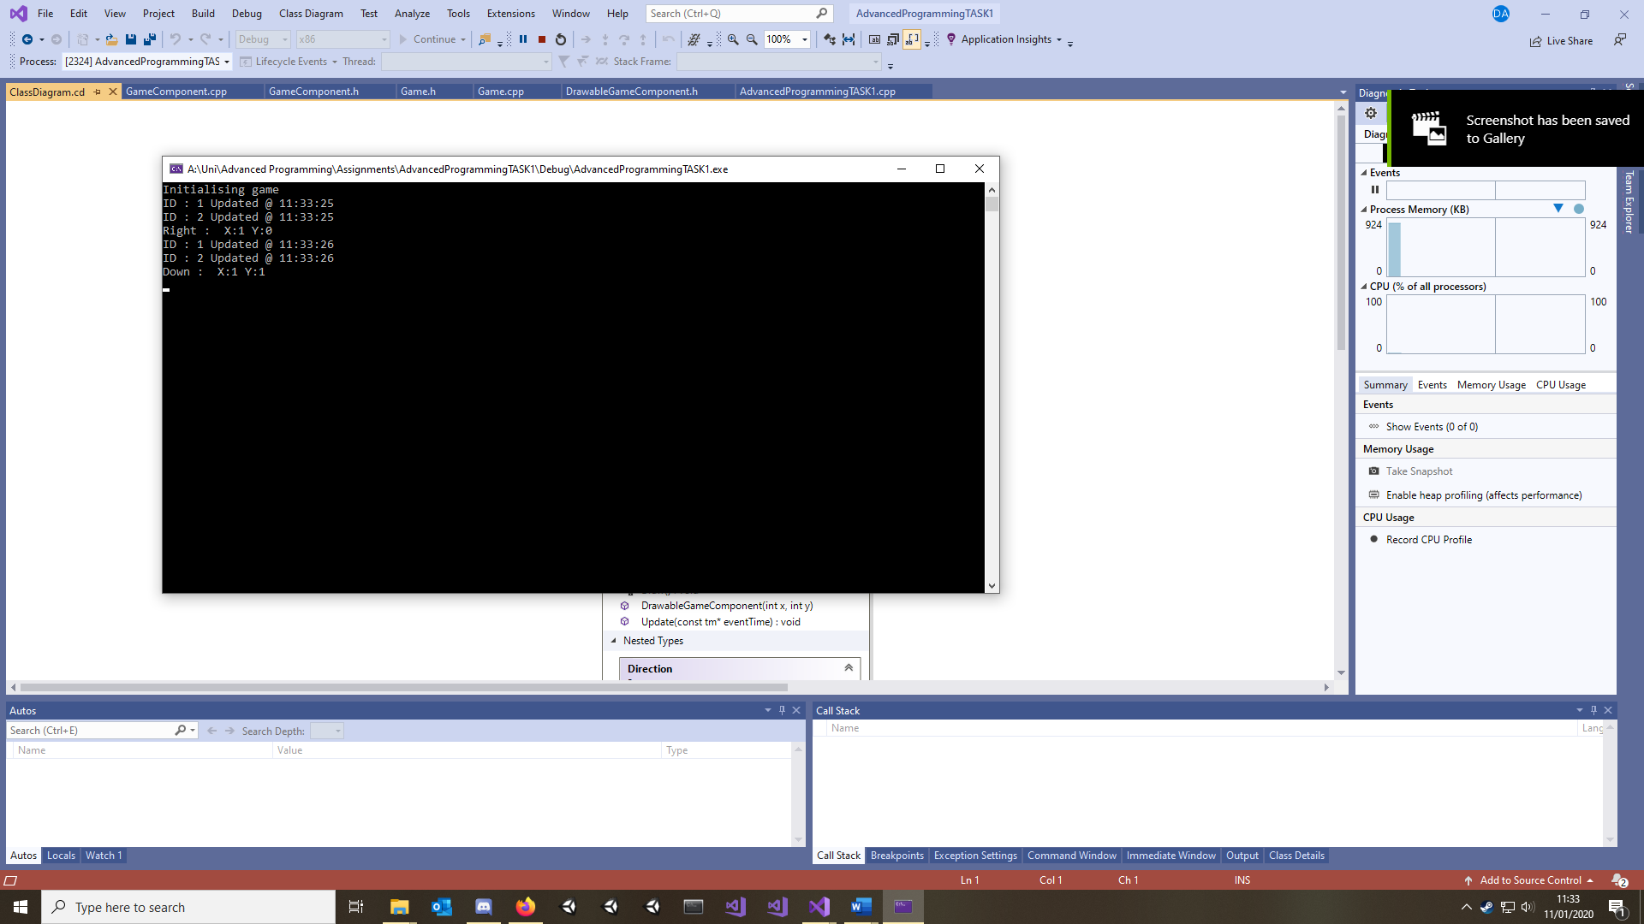

Figure (2 Seconds)

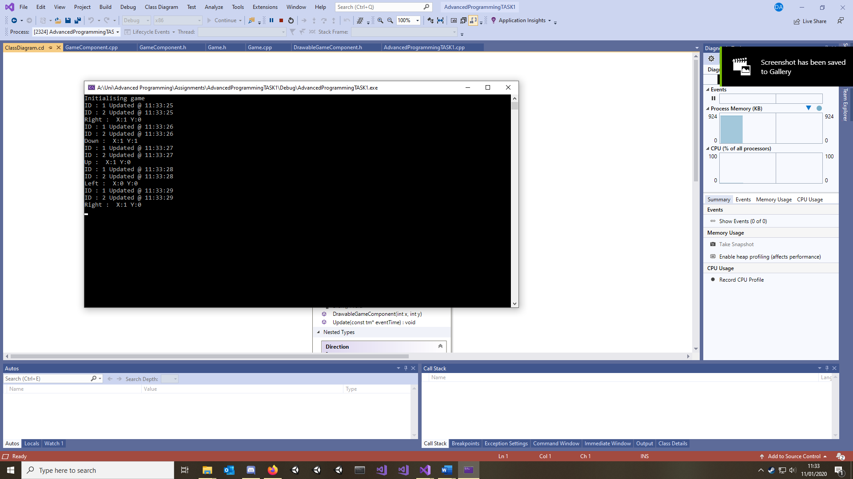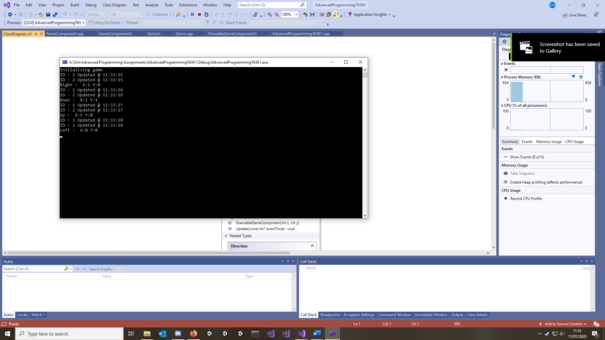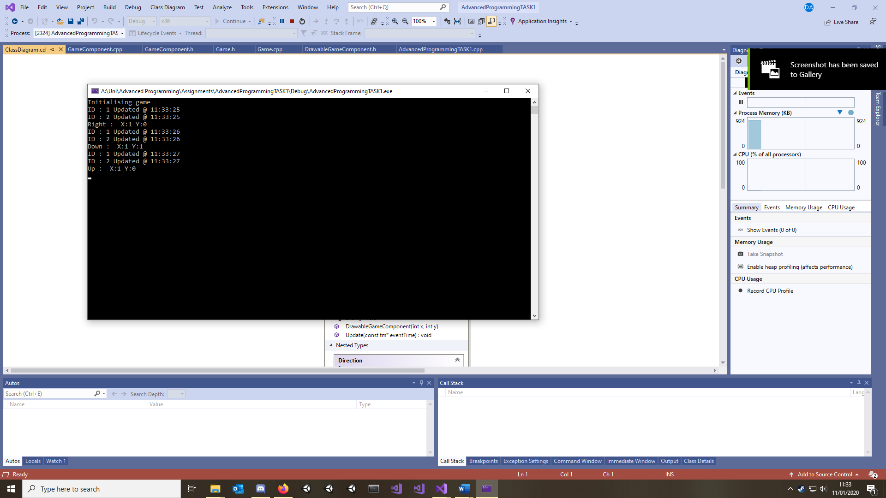

Figure (5 Seconds)

Figure (4 Seconds)

Figure (3 Seconds)

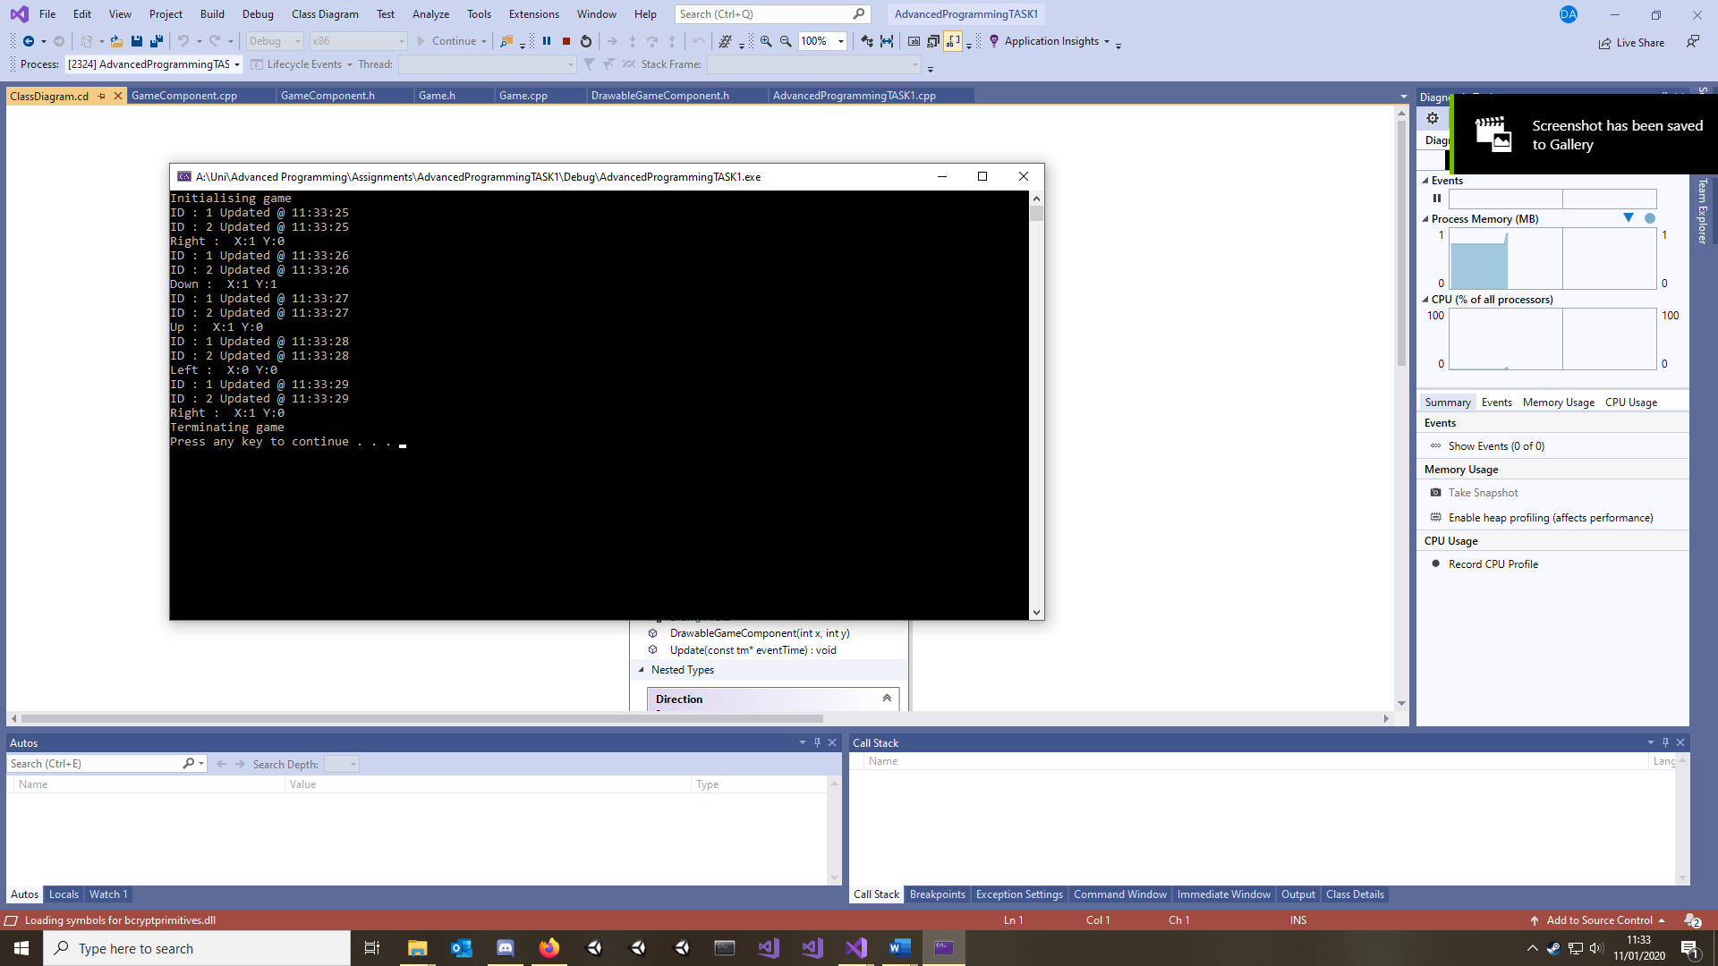

Figure , Game Terminating

# TASK 2

***As a side note; the console background was turned white to save ink.***

Figure , Code Launching as CLIENT through Pre-Processor Commands

Figure , Code Launching as SERVER through Pre-Processor Commands

Figure , Both Server and Client launch successfully

Both Server and Client check for Winsock through Comms. Each then sets up their sockets while the Server binds it.

Figure , Client enters a username, connection attempt successful

Figure , Client sends a message which is received on the Server

Figure , Client and Server both send messages

Figure , CLIENT about to enter QUIT

Figure , Connection successfully closed, allowing the CLIENT application to exit safely

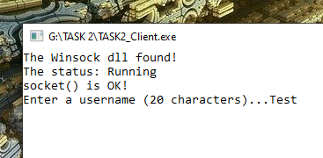

Figure , CLIENT application opened before SERVER.

Figure , CLIENT retries connection to connect to the SERVER without crashing

Figure , SERVER application is opened, and the CLIENT connects successfully

Figure , 3 CLIENT applications connecting to the same SERVER application at once

Figure , Message from one client is ECHOED to all other applications

Figure , SEVER application replies

Figure , CLIENT2 disconnects successfully

Figure , SERVER successfully only sends the message to the two connected CLIENTS

Figure , SEVER is abruptly closed. CLIENTS do not crash and exit gracefully